SmartRFP Documentation
1. Problem Statement
Background
Responding to enterprise Request for Proposal (RFP) documents is a time-consuming process that requires bid managers to review hundreds of pages, identify client requirements, retrieve information from previous proposals, estimate costs, and prepare a compliant proposal within tight deadlines.
Traditional proposal creation involves:
- Reading lengthy RFP documents manually
- Searching previous proposals for reusable content
- Preparing technical and commercial responses
- Verifying compliance
- Multiple review cycles before submission
This process is repetitive, expensive, and susceptible to inconsistencies and human error.
Problem
Organizations often spend several days preparing a single proposal because information is scattered across multiple documents and systems.
Major challenges include:
- Manual extraction of requirements
- Difficulty locating relevant past proposal content
- Time-consuming pricing estimation
- Risk of hallucinated AI-generated content
- Lack of traceability for generated responses
- Limited visibility into proposal quality
- Solution
SmartRFP is an AI-assisted proposal generation platform that automates much of the proposal drafting workflow using Retrieval-Augmented Generation (RAG), Large Language Models (LLMs), and structured human review.
The system:
- extracts requirements from uploaded RFPs
- retrieves relevant internal knowledge
- gathers pricing information
- generates a structured proposal draft
- performs evaluation and guardrail checks
- enables human review before approval

The final decision remains with human reviewers while AI accelerates the drafting process.

2. System Architecture
High-Level Workflow:
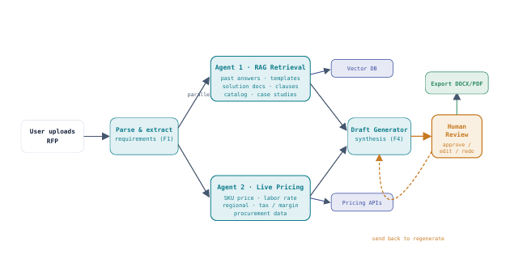
Frontend:
The user interface is implemented using Streamlit.
Responsibilities include:
- uploading RFP documents
- displaying proposal drafts
- showing evaluation metrics
- enabling human review
- exporting proposals
Backend
FastAPI exposes REST endpoints that separate the frontend from the proposal generation pipeline.
Responsibilities include:
- receiving uploaded files
- validating requests
- invoking the pipeline
- serving proposal data
- handling review actions
- AI Pipeline
The pipeline orchestrates all AI components.
Workflow:
- Requirement Extraction
- RAG Retrieval (Parallel – Agent 1)
- Pricing Agent (Parallel – Agent 2)
- Draft Generator
- Evaluation
- Database Persistence
The pipeline coordinates Agent 1 and Agent 2 in parallel using ThreadPoolExecutor.

RAG Component
The Retrieval-Augmented Generation system retrieves the most relevant knowledge base documents before each proposal section is generated.

Draft Generator
This combines:
- extracted requirements
- retrieved knowledge
- pricing information
to produce a structured proposal containing:
- Executive Summary
- Company Overview
- Technical Solution
- Security
- Deliverables
- Timeline
- Pricing
- Conclusion
- Evaluation
The generated proposal is evaluated using both rule-based metrics and RAGAS metrics.

Evaluation includes:
- Proposal completeness
- Context coverage
- Faithfulness
- Answer relevancy
- Hallucination flags
- Context precision
- Context recall
- Human Review

Human reviewers can:
- edit proposal sections
- approve proposals
- request changes
- regenerate drafts
- add comments
Database
The application stores:
- uploaded RFPs
- extracted requirements
- proposal drafts
- pricing
- evaluation metrics
- audit logs
- knowledge base documents
SQLite is used for development while PostgreSQL is recommended for production.

Resource & Cost — how those values are calculated
- Effort (hours) — a base overhead plus a per-requirement estimate: total_hours = 160 + (num_requirements × 130). Timeline in weeks is total_hours ÷ 130 (roughly one engineer-week of capacity), rounded up.

- Cost breakdown by role — total hours are split across roles by fixed percentages (Development ~36%, Solution Architecture ~26%, PM ~15%, BA ~11%, QA ~8%, Training/Support ~5%), and cost is the same split applied to the total.

- Total cost — sum of the pricing line items the Pricing Agent produced: labour + cloud + licenses + contingency + profit + tax. Line items are computed in code; Tavily adds live market context to the narrative only.

- Cost Confidence — High/±8% when nothing is stale and there are no flags; Medium/±15–20% as flags rise. It's a rules-based band, and you should present it as an indicative estimate, not a quote.

Observability
- Prometheus metrics are exported from the backend (metrics.py,pipeline runs/failures/runtime, requirements extracted, sections generated, hallucination-flag gauge, LLM request/error/latency counters, and RAG query/result/empty counters.
- LangSmith tracing — the pipeline and each agent are decorated so every run produces a full trace tree (extraction → retrieval → generation → evaluation) with timings and inputs/outputs for debugging.

- Structured logging throughout the pipeline , live Groq check), and Pinecone readiness. The sidebar's live status dots read from these.

